TITLE OF PAPER (Times New Roman, 16 pt., Bold centered)
TITLE OF PAPER IN ENGLISH, IF THE ARTICLE WAS WRITTEN IN CZECH OR SLOVAK LANGUAGE (Times New Roman, 16 pt., centered)
First and last name of author – first and last name of co-author(s) (without titles) (Times New Roman, 14 pt., bold, centered)

Abstract
The text of abstract – 150 - 200 words ! (Times New Roman, 12 pt. , alignment in block, spacing 1,5) xxxxxxxxxxxxxxxxxxxxxxxxxxxxxxxxxxxxxxxxxxxxxxxxxxxxxxxxxxxxxxxx
xxxxxxxxxxxxxxxxxxxxxxxxxxxxxxxxxxxxxxxxxxxxxxxxxxxxxxxxxxxxxxxxxxxxxxxxxxxxxxxxxxxxxxxxxxxxxxxxxxxxxxxxxxxxxxxxxxxxxxxxxxxxxxxxxxxxxxxxxxxxxxxxxxxxxxxxxxxxxxxxxxxxxxxxx
Key words: key word, key word, key word (3-5)
JEL Code: JEL Code, JEL Code, JEL Code (2 – 3)

Introduction (Times New Roman, 14 pt., bold)
Text of introduction (Times New Roman, 12 pt. , alignment in block, spacing 1,5) xxxxxxxx
xxxxxxxxxxxxxxxxxxxxxxxxxxxxxxxxxxxxxxxxxxxxxxxxxxxxxxxxxxxxxxxxxxxxxxxxxxxxxxxxxxxxxxxxxxxxxxxxxxxxxxxxxxxxxxxxxxxxxxxxxxxxxxxxxxxxxxxxxxxxxxxxxxxxxx

1 Title of chapter (Times New Roman, 14 pt., bold)
The main text. (Times New Roman, 12 pt., alignment in block, spacing 1,5) The extent of the paper can be 8-10 pages. The main text. The main text. The main text. The main text. The main text. The main text. The main text. The main text. References in text should have this form (surname, year), for example: (Friedman, 1970).
The main text. The main text. The main text. The main text. The main text. The main text. The main text. The main text.

  - Title of subchapter (Times New Roman, 12 pt. bold)
The main text. (Times New Roman, 12 pt., alignment in block, spacing 1,5) The main text. The main text. The main text. The main text. The main text. The main text. The main text. The main text. The main text.
The main text. The main text. The main text. The main text. The main text. The main text. The main text. The main text.

Fig. 1: Title of figure (Times New Roman, 12 pt. bold)
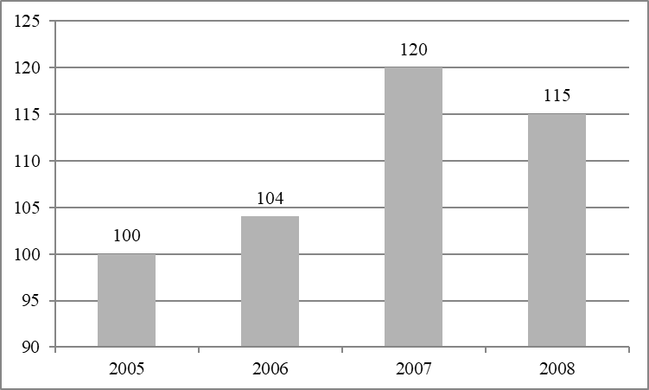
Source: xxxxxxxxxxxxx
The main text. The main text. The main text. The main text. The main text. The main text. The main text. The main text.

Tab. 1: Title of table (Times New Roman, 12 pt. bold)
10 pt. Times New Roman
Source: xxxxxxxxx
The main text. The main text. The main text. The main text. The main text. The main text. The main text. The main text.
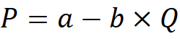 (1)
The main text. The main text. The main text. The main text. The main text. The main text. The main text. The main text.

Conclusion (Times New Roman, 14 pt., bold)
The main text. (Times New Roman, 12 pt., alignment in block, spacing 1,5) The main text. The main text. The main text. The main text. The main text. The main text. The main text.
The main text. The main text. The main text. The main text. The main text. The main text. The main text. The main text.

Acknowledgment (Times New Roman, 14 pt., bold)
If any

References (Times New Roman, 14 pt., bold)
Pleas, use 10 – 15 references. All citations in the text and all references must meet APA styles (American Psychological Association – more information http://www.apastyle.org/)! Please, use automatic citation maker for citation and references: automatic APA citation maker.(http://citationmachine.net/index2.php?reqstyleid=2&newstyle=2&stylebox=2)

Avery, R. J., Bryant, W. K., Mathios, A., Kang, H., & Bell, D. (2006). Electronic course evaluations: Does an online delivery system influence student evaluations? The Journal of Economic Education, 37(1), 21–37. https://doi.org/10.3200/JECE.37.1.21-37
Berk, R. A. (2012). Top 20 strategies to increase the online response rates of student rating scales. International Journal of Technology in Teaching and Learning, 8(2), 98–107.
Minimum 5 references have to be from Web of Science Database.

Contact (Times New Roman, 12 pt., bold)
First and last name of author (Times New Roman, 12 pt., spacing 1,5)
Institution
Full address of institution
Mail

First and last name of co-author (s)
Institution
Address of institution
Mail

Footnote.

